On either, the older or new GO-4’s the black wire is the one you’ll want to cut/unplug.
The pictures show the location on a 1996 GO-4.
I never had any luck just unplugging the whole thing.
Both my 96 and 04 don’t run like they should if the governor is just unplugged.
Schematics indicate the ECU’s still getting a signal from the module. This signal, which in turn is used by the ECU, to tell the module to remove the ground from two(?) of the injectors.
If you trace the black wire (from the plug) you’ll find it runs to the injectors and is a redundant wire. The injectors also have a wire back to the ECU for power.
The result is the injectors don’t open, thus slowing the vehicle.
This tells me that the black wire only controls the ground signal to those injectors. There is no checking of the signal to verify the injectors have indeed been turned off.
So, disabling the black wire only lets the ECU/governor think they are still functioning as they should.

Below is what I had in my informational file.

How do you disable electronic governor on a Westward go-4 vehicle with Hyundai Engine?
The governor is generally located inside a metal tray bolted to the firewall, directly in front of the engine under the rear. Remove the two bolts holding the top of the tray on. This reveals the wiring harness, ECU, TCU, etc. The governor is a small black box about 2 in by 2 in and is wired into the wiring harness on the left side of the tray. There are six wires running from it to a connector. It has a number on a white label #664008 or similar to that. Cut the black ground wire and tape. That's all there is to it.
How do you disable electronic governor on a Westward go-4 vehicle with Ford/Mazda Engine?
The governor is generally located behind the metal side plate bolted on the right side. You’ll have to close the door and remove two bolts for access. This reveals the wiring harness and the governor (usually fastened to the underside of the cab) . The governor is a small black box about 2 in by 2 in and is wired into the wiring harness thru a plug. There are six wires running from it to a connector. It may have a number on a white label. Cut the black ground wire and tape. That's all there is to it.

I do not recommend driving this vehicle at real high speeds as three wheel vehicles are not as stable as four wheeled vehicles. Please be careful, these vehicles can exceed 80 mph.
Remember that going around turns, it's not stable at high speeds. Please be careful and use the governor in your brain.
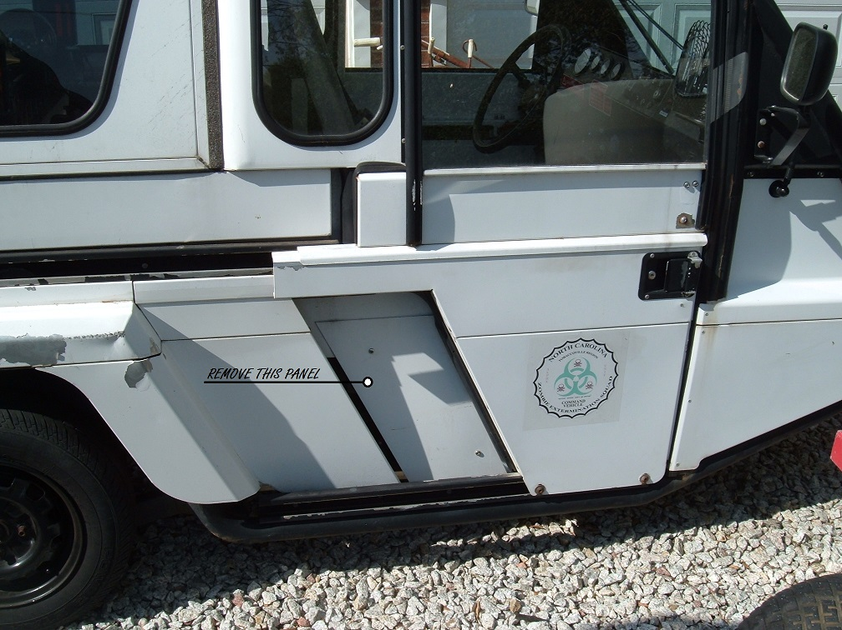
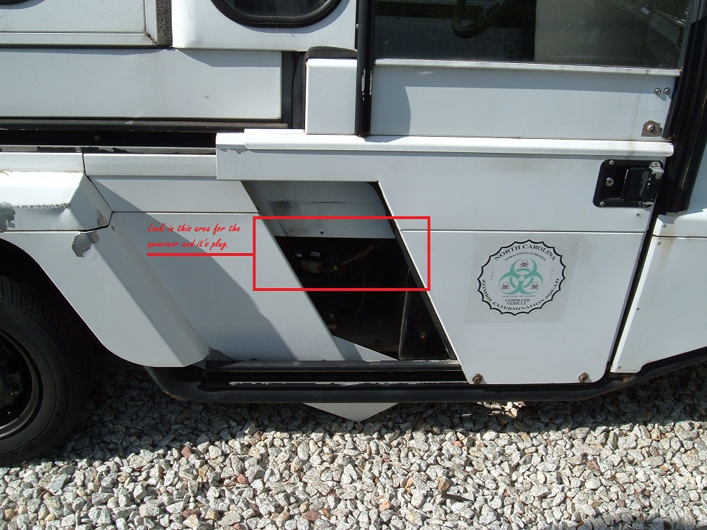
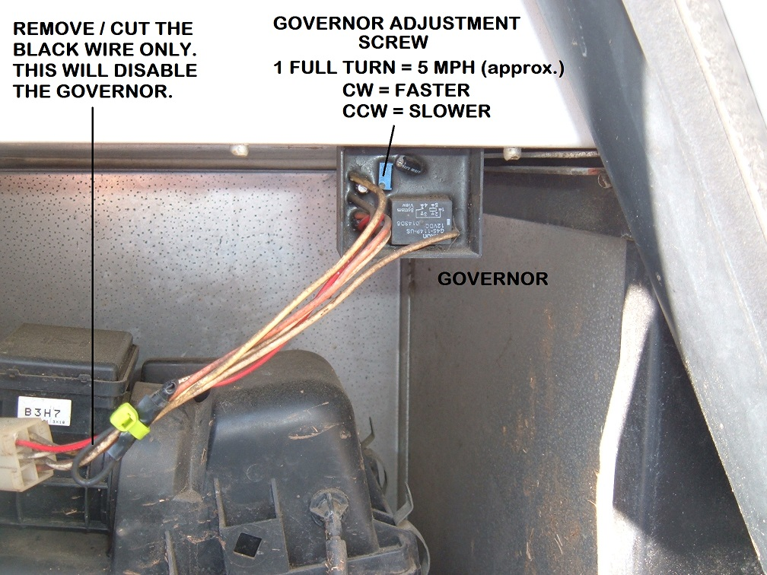

How to adjust the GO-4 governor:

One revolution (turn) clock-wise increases speed by 5 mph.
One revolution (turn) counter clock-wise decreases speed by 5 mph.
Set at factory for 40 mph

